A1.
Prove by mathematical induction.

A2.
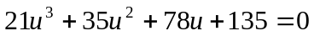

A3.
(i) 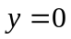 , 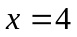 , 
(ii) local minimum is when 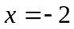 , local maximum is when .

A4.
(i) 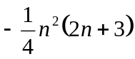
(ii) 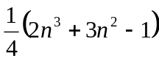

B1.
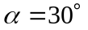 , 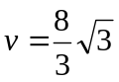

B2.
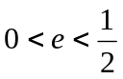

B3.
  